Training Program of Overseas Doctoral Students in Computer Science and Technology
First level discipline Code: 0812

1. Training Objective
In order to meet the needs of the modern computer science and technology development, this training program is designed to foster high-level research professionals of theoretical computer science and applied technology. Basic requirements for overseas doctoral students are listed as follows.
- Students should understand Chinese culture, abide by the law and the rules of conduct, have good moral character and rigorous style of study, and be provided with a strong sense of professionalism and dedication.
- Students should master the basic theory of computer science and technologies, systematically knew the theory of computer application technology, and deeply understand the knowledge about computer software and theory, computer system architecture.
- Students should have further insight into the development direction of the discipline and the international research focuses. Students should have the ability to undertake research work independently, and get creative achievements in the research.
- Students can undertake important computer application technology research projects and the development of large-scale application software systems.
- Students who graduate from this program and have the doctor’s degree are competent for the work about teaching, research, and technology development in the filed of computer application technology among universities and research institutes. Students should master at least one foreign language, be able to use the foreign language to read and write the professional foreign materials expertly, and have good international academic communication skills.

2. Research Directions
  - Computer Application Technology (081203)
(1) Multimedia and Intelligent Information Processing.
(2) Trusted Computing and Internet of Things System.
(3) Service Computing and Information Security..
(4) Data Mining and Information Retrieval.

3. Period of Study and Requirements
Duration of study is typically last three years for full-time doctoral students. If some students cannot finish the program as expected, the extension period is generally no more than three years.
Every PhD student is required to publish at least 3 research papers in the relevant journals indexed by EI\SCI (two research papers in the relevant SCI journals, or one research paper in the second district of JCR) prior to being eligible to apply a dissertation defense. The dissertation must demonstrate a mastery of research techniques, ability to perform original and independent research, and skills in formulating conclusions that enlarge upon or modify accepted ideas.
The above achievements are required to be with the first affiliation of Jiangsu University. The first author should be yourself, or your PhD supervisor as well as you being the second author.
All Ph.D. students are required to attend lectures, seminars, exchanges and other scientific and technological activities of not less than 20 times. The Ph.D. students should be directed by a qualified major supervisor (Ph.D. graduate faculty), as well as a committee panel containing several qualified co-advisors/committee members. The supervisor is not only responsible for the development of students training program, guiding scientific research, professional practice and degree papers, etc., but also responsible for guidance, demonstration and supervision of doctoral students' Ideological and moral, academic ethics.

4. Credit Requirements and Curriculums Provisions
The courses for Ph.D. students have two types: compulsory courses and elective courses. The courses study will last approximately for a year.
Total credits of the courses are required 14 credits at least. The compulsory courses are required 10 credits among all of credits at least.
Curriculum
Categories |  | Course Name | Credits | Semester | college | Attention
Compulsory Courses | Cultural Fundenment | Chinese Culture | 2 | 1 | Overseas Education College | Compulsory
Compulsory Courses | The First Foreign Language | Chinese | 3 | 1 | Overseas Education College | Compulsory
Compulsory Courses | Basic  Theoretical Courses | Advanced Concrete Mathematics | 2 | 1 | School of Computer Science and Communication Engineering | At least one course must be selected
Compulsory Courses | Basic  Theoretical Courses | Introduction to Complex Networks | 2 | 1 | School of Science | At least one course must be selected
Compulsory Courses | Basic  Theoretical Courses | Matrix theory | 2 | 1 | School of Science | At least one course must be selected
Compulsory Courses | Specialized Core Courses | Basic Theory of Computer Science and Technology | 3 | 1 | School of Computer Science and Communication Engineering | Required
Elective  Courses | Specialized  Elective  Courses | New Progress in Computer Science and Technology | 2 | 1 | School of Computer Science and Communication Engineering | Required
Elective  Courses | Specialized  Elective  Courses | Advanced Machine Learning | 2 | 1 | School of Computer Science and Communication Engineering | At least one course must be selected
Elective  Courses | Specialized  Elective  Courses | Advanced Technology of Information Security | 2 | 1 | School of Computer Science and Communication Engineering | At least one course must be selected
Elective  Courses | Specialized  Elective  Courses | Case of Trusted Internet of things system | 2 | 1 | School of Computer Science and Communication Engineering | At least one course must be selected
Elective  Courses | Specialized  Elective  Courses | Cloud Computing Technology | 2 | 1 | School of Computer Science and Communication Engineering | At least one course must be selected
Elective  Courses | Specialized  Elective  Courses | Advanced Information Retrieval | 2 | 1 | School of Computer Science and Communication Engineering | At least one course must be selected
Elective  Courses | Specialized  Elective  Courses | Advance Electromagnetics and Antenna Theory | 3 | 2 | School of Computer Science and Communication Engineering | At least one course must be selected
Elective  Courses | Specialized  Elective  Courses | Computational Electromagnetics | 2 | 2 | School of Computer Science and Communication Engineering | At least one course must be selected

5 Practice Credit Requirements
Practice credits and theory credits can not transferred to each other, only when both of the practice credits and theory credits requirements are satisfied, the Ph.D students may proceed to submission and defense of their dissertations. The total practice credits are no less than 9.
(1) Academic activities (2 credits)
Ph.D students must participate in various kinds of academic activities, which include “Lectures on academic ethics” organized by JSU, lectures presented by well-known scholars, seminars as well as graduate forum, during the Ph.D period, the students must present no less than 15 times.
After academic activities, the students must prepare a complete academic report, which will be further assessed by the department; the students will get 2 credits when the report is qualified. If the Ph.D students could publish papers on international conference or high level national conference, it is also considered they are qualified for the academic reports.
(2) Literature Review (2 credits)
Ph.D students should read a number of literature for the development of the ability to acquire knowledge by themselves. The ability to do literature review will be assessed by the group of experts. the students will get 2 credits when qualified, otherwise, they will not be able to proceed to the opening.
(3) Academic report (1 credit/time)
Ph.D students need to do presentation publicly no less than two times, the content of the present could be the report of research progress, or review literatures in related fields. The leader of discipline will assess the report, these students who are qualified will get 1 credit per time.
(4) Practice (1 credit)
Ph.D students should assist their supervisors in teaching undergraduate students or graduate students, each one of them need to teach 3-4 lessons during Ph.D period. The supervisors will be responsible for the assessment; those students who are qualified will get 1 credit.
(5) Comprehensive Discipline Assessment (2 credits)
Comprehensive discipline assessment will be conducted before preparing the dissertation, it mainly evaluated the academic ethics, theoretical knowledge and research ability of the Ph.D candidates.
Comprehensive discipline assessment should be finished before the end of the 2nd semester, it is organized by the discipline, the forms mainly include written examination, and interview. The group which consists of 5 experts will be established for the interview, one of them is selected to be in charge of the interview. There are 3 results of the assessment, namely, excellent, qualified, and postponed, while the percentage of postponed students must be no less than 15% of the total number of students taking the assessment. For those students who are excellent or qualified, they will be given 2 credits. While for those students who are postponed, they will be re-evaluated or terminated based on the specific situations. Every Ph.D student has 2 chances for the comprehensive discipline assessment, for the students who are postponed for the first time, they are allowed to participate in the 2nd assessment, however, the interval between the 2 assessments should be no less than 6 months, if the students are postponed again, the will be terminated.

6.Dissertation
The PhD research of this discipline consists of fields in the computer application technology and the research of application foundation, and promotes the study of theory and technologies in the leading and the cross subjects. Degree thesis should represent that the PhD students have a firm and comprehensive grasp of basic theories and profound and systematic specialized knowledge in the discipline concerned, master the scientific research approaches and experiment skills of their research areas, and have the ability to undertake the research task independently.
Degree thesis should be fluent, logical and well reasoned. The main opinions should have sufficient novelty. The degree thesis must consist of abstract (English & Chinese), introduction, main body, conclusion and references, and so on.
The degree thesis process is distributed into four stages: proposal, progression report, dissertation writing up and dissertation defense.
(1) Proposal
PhD students must conduct massive literature review and related investigation before writing up. This aims to investigate the history and current situation of their research areas, and then identify the research topic and complete the proposal. The proposal should describe some key issues of the research, such as: topic basis, research approaches, expected goals and novelty and schedule.
Proposal presentations of PhD students are organized after a permission of the supervisor in each research group. The research group sets up an assessment team (excluding the supervisor and other committee members) for the proposal presentations. The assessment team has at least 5 specialists from this subject or the related subject, and one of them manages the assessment work. The proposal assessment adopts team-scoring system. The amount of the postponed PhD students must be greater than 10% of the total. The time and location of the presentation will be published online. Each PhD student is allowed to attend the proposal presentation at most two times, and the second time must be arranged after at least three months. The PhD students who have been postponed twice must drop out.
The dissertation defense must be arranged two years later after getting a pass of the proposal.
(2) Progression Report
The progression report must be conducted around 1 year later after the proposal.
(3) Publications and Achievements
PhD students are encouraged to publish academic thesis and make more research attributes. More details can be found from the regulations of academic publications of Jiangsu University and the requirements of the degree assessment committee of the school.
(4) Dissertation Writing-up
The PhD student must complete degree dissertation independently under the direction of the supervisor. Dissertation format can be found from “Jiangsu University Degree Thesis Writing-up Format Requirements”.
(5) Dissertation Assessment and Defense
Dissertation assessment and defense requirements can be found from “Jiangsu University Academic Degree-conferring Detailed Codes” and “Jiangsu University Degree Thesis Blind Review Implementation Details”.

7. Other Requirements
Requirements of qualifying examinations, dissertation and other aspects are referred to the Doctoral Student Training Program of Jiangsu University (General Principles) in detail.

Appendix: Recommended Academic Monographs and Academic Journals
(1) Main Academic Monographs
- Introduction to Automata Theory, Languages, and Computation, John E. Hopcroft Jeffrey D. Ullman. Science Press, 1991.
- Principles of Database System, J. D. Ullman.
- Randomized Algorithms, Rajeev. Motwani and Prabhakar Raghavan,Cambridge University Press, 1995.
- Approximation Algorithms for NP-hard Problems, D.S.HOCHBAUM,PWS,1997.
- Algorithm analysis and design, Ma Shaohan, Shandong University press, 1993. (in Chinese)
- Computer graphics tutorial, Tang Rongxi, Wang Jiaye, Science Press, 2001 Edition.(in Chinese)
- Introduction to Computer Graphics, J. D. Foley, Addison-Wesley Publishing company, 1994,ISBN:0-201-60921-5.
- Computer Network, Andrew S. Tanenbaum.
- Computational geometry, Su Buqing, Liu Dingyuan, Shanghai Science and Technology Literature Press. (in Chinese)
- Multimedia system design, Andleigh,Thakrar.
- Combinatorial optimization--- Algorithms and complexity, C.H.Papadimitriou K.Steiglitz.
- The principle of artificial intelligence, Shi Chunyi, Tsinghua University press, 1993.10.(in Chinese).
- Design and analysis of parallel algorithms, Chen Guoliang, higher education press, 1994.5. (in Chinese)
- Computer System Architecture, M. Morris Mano.
- Logic in Computer Science (Second Edition), Lu Zhongwan, Peking University Press. (in Chinese)
- Software Architecture-Perspective on an Emerging Discipline, Mary Shaw, et al.
- Cryptography Theory and Practice, (Second Edition), Stinson.
- Distributed computing system, and Jiubin, higher education press, 1994.6. (in Chinese)
- Artificial neural network model and application, Zhang Liming, Fudan University press, 1993.7. (in Chinese)

2. Main Chinese Academic Journals

- Science China
- Chinese Science Bulletin
- Journal of Computers
- Journal of Software
- Journal of Computer Research and Development
- Journal of Computer-aided Design & Computer Graphics
- Acta Electronica Sinica
- Journal on Communications
- Acta Automatica Sinica
- Pattern Recognition and Artificial Intelligence
- Journal of Chinese Computer Systems
- Computer Science
- Journal of Image and Graphics
- Journal of Chinese Information Processing
- Journal of Electronics & Information Technology
- Computer Engineering

(3) Main Foreign academic journals

- IEEE Computer Graphics and Application
- IEEE Trans on Software Engineering
- IEEE Trans on Computers
- ACM Trans on Database System
- ACM Transactions on Graphics
- Algorithmic
- Artificial Intelligence
- Applied Artificial Intelligence
- IEEE Trans on Neural Network
- IEEE Trans on Information Theory
- Journal of ACM
- SIAM Journal on Computing
- Journal of Algorithms
- Lecture notes in computer science series
- Theoretic Computer Science
- Journal of Discrete Applied Mathematics
- Lecture Notes in Computer Science, Springer-Verlag
- Journal of Computer Science and Technology

8. Course Content
New Progress in Computer Science and Technology
Goal
This course emphasizes new progress and hot research topics for theory and technology in computer science and technology.
Essential Objectives
- Make student understand new progress and hot research topics in the field of computer science and technology comprehensively
- Promote student’s dissertation topic selections.
- enlighten student’s research ideals.
Content Coverage
The main contents include new progress and advanced research topics in the research areas, such as multimedia technology, intelligence information processing, trusted computing, Internet of things, cloud computing, information security, data mining, information retrieval.
Evaluation
Grades will be based on your performance of the following components:
_ 24 class hours of lectures 50%
_ Final eassy of survey 50%

Advanced Information Retrieval

Goal
This course on advanced information retrieval focuses on the theory or concepts of information retrieval systems, introduces the up-to-date treatment of all aspects of the design and implementation of systems for gathering, indexing, and searching documents and of methods for evaluating systems. And some machine learning technologies in information retrieval are also included, such as Text classification, Topic model, Neural networks and so on. The goal of this course is to help students understand basic technologies and advanced trends in information retrieval, and to encourage them to use relative technologies to deal with their research problems.

Essential Objectives
a. Outline basic terminology, components and frameworks in information retrieval systems
b. Know and compare some information retrieval models such as Vector Space Models, Probability Models, and Language Models
c. Know how to evaluate the retrieval performance and grasp some evaluation metrics
d. Outline the structure or representation of queries and documents
e. Articulate fundamental functions in information retrieval systems such as automatic indexing, abstracting, and clustering
f. Understand some unique issues of web search, such as link analysis, web crawling, web mining
g. Know the application of machine learning in information retrieval
h. Grasp current trends in information retrieval and know some relative applications or technologies such as Computational advertising, Recommending systems

Content Coverage
The course focuses on the introduction of advanced information retrieval technologies and innovations are also encouraged in any aspect. PH. D candidates will acquire the basic understanding of information retrieval technology and grasp the improvement trend of information retrieval. They can work singularly or together to apply some technologies to their interesting applications. The course will focus on retrieval models, evaluation, relevance feedback and query expansion, text pre-treating and mining, indexing and searching, web search, text classification, topic model and as well as some frontier techniques of information retrieval issues.
Evaluation
This course has 20 class hours of lectures, and grades will be based on your performance of the following components:
_ Participation and Discussion 20%
_ Weekly Summaries 40%
_ Final Essay 40%

Advanced Technology of Information Security
1. For Computer Science & Technology or related majors, include but not limited, Software Engineering, Network Engineering, Internet of Things. The focus of this course is that give an advanced overview of information security technology, e.g., access control, cryptography, digital signature, etc.
2. 2 credits, 30 hours
3. Advanced Mathematics and Discrete Mathematics are prerequisite for this course
4. Objectives: Know the core concepts of Information Security. Understand and thereby can implement the algorithms of access control and cryptographies by one of computer languages that you are familiar with. Understand the protocols of key distribution.
5. Main Content
Model 1: Common Road Map to Information Security），4 hours
Sub model 1：Security Policy
Sub model 2：Security Mechanism
Sub model 3： Threat from Social Engineering
Model 2：Access Control Technology，4 hours
Sub model 1：Access Control Policy
Sub model 2：Access Control Mechanism
Sub model 3：Access Control Matrix
Model 3：Access Control Models，4 hours
Sub model 1：Confidential Access Control Model BLP
Sub model 2：Integrity Access Control Model, BLP, Biba, Clark-Wilson and Chinese-Wall

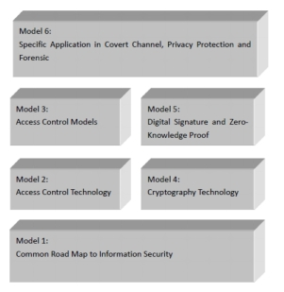
Fig.1 Logic Chart of Teaching Models

Model 4：Cryptography Technology，8 hours
Sub model 1：Classical Cryptography
Sub model 2：Symmetric Cryptography
Sub model 3：Asymmetric Cryptography
Model 5：Digital Signature and Zero-Knowledge Proof，8 hours
Sub model 1：Hash Functions
Sub model 2：Digital Signature
Sub model 3：Zero-Knowledge Proof
Model 6：Specific Application in Covert Channel, Privacy Protection and Forensic，4 hours
Sub model 1：Covert Channel
Sub model 2：Provenance

Advanced Machine Learning
Goal
Our goal is to help Ph. D. student to
–Understand fundamentals of machine learning
–Learn technical details of ML algorithms
–Learn how to implement some important algorithms
–Use machine learning algorithms for your research and applications.
Content
Chapter 1 Introduction (2 class hours)
The Concept,Classification,Motivation and Application of Machine Learning
Underfit and Overfit
Chapter 2 Relevant Theoretical Basis of Machine Learning (4 class hours)
2.1 Gradient Descent
2.2 Newton Method
2.3 Kernel Method
Chapter 3 Feature Dimension Reduction (6 class hours)
3.4 Principal Component Analysis (PCA)
3.5 Linear Discriminant Analysis (LDA)
3.6 Latest Development of Feature Dimension Reduction
Chapter 4 Advanced Neural Network (6 class hours)
4.1 Random Forward Neural Network
4.2 Integrated Neural Network
Chapter 5 Latest Research Focuses （6 class hours）
5.1 Sparse Representation
5.2 Deep Learning
Evaluation:
_ 24 class hours of lectures or seminar
_ Final Eassy

Cloud Computing
Goal
This module will equip first-year PhD students with the necessary knowledge for critically reflecting upon and applying Clouds and supporting emerging technologies (e.g. Virtualization technologies, Web Services and Cloud Computing) in real world IT scenarios. As such, the aim of this module is to provide an in depth coverage and critical evaluation of the concepts, techniques and applications of Cloud Computing by following a research-oriented approach.
Essential Objectives
- Demonstrate adequate skills in carrying out a small-scale, research-oriented project in the domain of Clouds under supervision
- Comprehend in detail the nature, concepts and techniques of the Cloud Computing technology and its standards
- Solve a non-trivial theoretical or practical problem in a selected topic in the context of Cloud Computing applications
- Critically evaluate current emerging technologies
- Adequately assess the significance and correctness of published research on Cloud Computing
Content Coverage
- Fundamental Cloud Computing Terminology and Concepts
- Cloud Computing Architecture: Infrastructure, Platforms and Software
- Basics of Virtualization
- Benefits, Challenges and Risks of Contemporary Cloud Computing Platforms and Cloud Services
- Supporting Technologies: Service Computing, P2P networking
- Sustainable Cloud Computing
- Big Data Analytics
- Case studies
Evaluation
_ 24 class hours of lectures and tutorials
_ Midterm report
_ Final Eassy

Related Basic Theory of Computer Science and Technology
Goal
The focus of this course is to make students to master the involved knowledge in the discipline of computer science and technology firstly, and thus lay a solid foundation for deep learning of the successive courses and research. Moreover, the focus of this course is to inspire computational thinking, enhance the ability of discovering problems and solving problems (especially complex problems of science and engineering).

Essential Objectives
  - Understand the halting problem
  - Understand diagonalization
  - Understand Turing computability
  - Understand optimization problems
  - Under the concepts of neural networks and master basic algorithms of common neural networks
  - Under the concepts of evolutionary computation and master genetic algorithm
  - Under the concepts of swarm intelligence and master particle swarm optimization
  - Demonstrate a critical awareness of the principle concepts of complex networks, the protocols and technologies involved, the current developments and research in this area
  - Demonstrate the ability to critically evaluate the suitability of different techniques that can be applied when design a complex network
  - Adequately assess the significance and correctness of published research on complex networks

Content Coverage
The course focuses on teaching the involved basic theory and methods on computer science, computer application technology, computer networks and information security. This course mainly contains computability theory, the theory and algorithms of computational intelligence, complex network theory and its applications.

Evaluation
_ In-Class discussion 40%
_ Final essay reports on computability theory, computational intelligence and complex network 60%
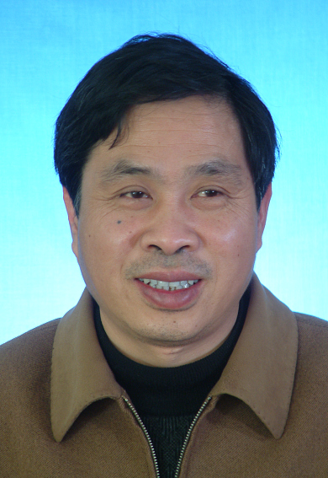
Yongzhao Zhan
Dean of School of Computer Science and Communication Engineering
Professor, supervisor for Ph.D. and M.S. students
Zhenjiang, 212013, P. R. China
Education Background
Ph.D. Department of Computer Science and Technology, Nanjing University, Nanjing, P.R. China, 2000
M.E., Department of Information Engineering, Jiangsu University, zhenjiang, P.R. China, 1990
B.E., Department of Computer Science, Fuzhou University, P.R. China, 1986
Working Experience
1984-Present, Assistant Professor, Associate professor, Professor, School of Computer Science and Communication Engineering, Jiangsu University, P.R. China
2009.6-2009.9 Senior visiting scholar in Department of Computer and Information Science of Konstanz University, Germany
1995.10-1996.9 Senior visiting scholar in Department of Computer and Information Science of Konstanz University of Applied Science, Germany
Research Interesting
- Multimedia Technology
- Human Computer Interaction
- Pattern Recognition
Contacts
Email: yzzhan@ujs.edu.cn; Tel: 0511-88791102


Shengli Wu, Ph.D.
Distinguished professor of Jiangsu Province, Jiangsu University
Professor, supervisor for Ph.D. and M.S. students
Zhenjiang, 212013, P. R. China
Education Background
Ph.D. School of Computer Science and Engineering, Southeast University, Nanjing, P.R. China, 1996
M.E., School of Computer Science and Engineering, Southeast University, Nanjing, P.R. China, 1989
B.E., School of Computer Science and Technology, University of Science and Technology of China, P.R. China, 1983
Working Experience
1984-Present, Assistant Professor, Associate professor, Professor, School of Computer Science and Communication Engineering, Jiangsu University, P.R. China
2012-Present, Distinguished professor of Jiangsu Province, Professor, School of Computer Science and Communication Engineering, Jiangsu University, P.R. China
2003-2012, Lecturer, School of Computer and Mathematics, Ulster University, UK
2001-2003, Researcher, School of Computer and Information Science, British University of Strathclyde, UK
2000-2001, Researcher, School of Computer, Manchester University, UK
1999-2000, Researcher, School of Computer Science, National University of Singapore
1998-1999, Postdoctoral Study, School of Computer System, Georgia University, America
1996-1998, Postdoctoral Study, Institute of Software of Chinese Academy of Sciences, P.R. China
1989-1993, Lecturer, School of Computer Engineering, Jiangsu Institute of Technology(now Jiangsu University), P.R. China
Research Interesting
- Database and Information System
- Information Retrieval
- Machine Learning
Contacts
Email: swu@ujs.edu.cn; Tel: 0511-88797508-405

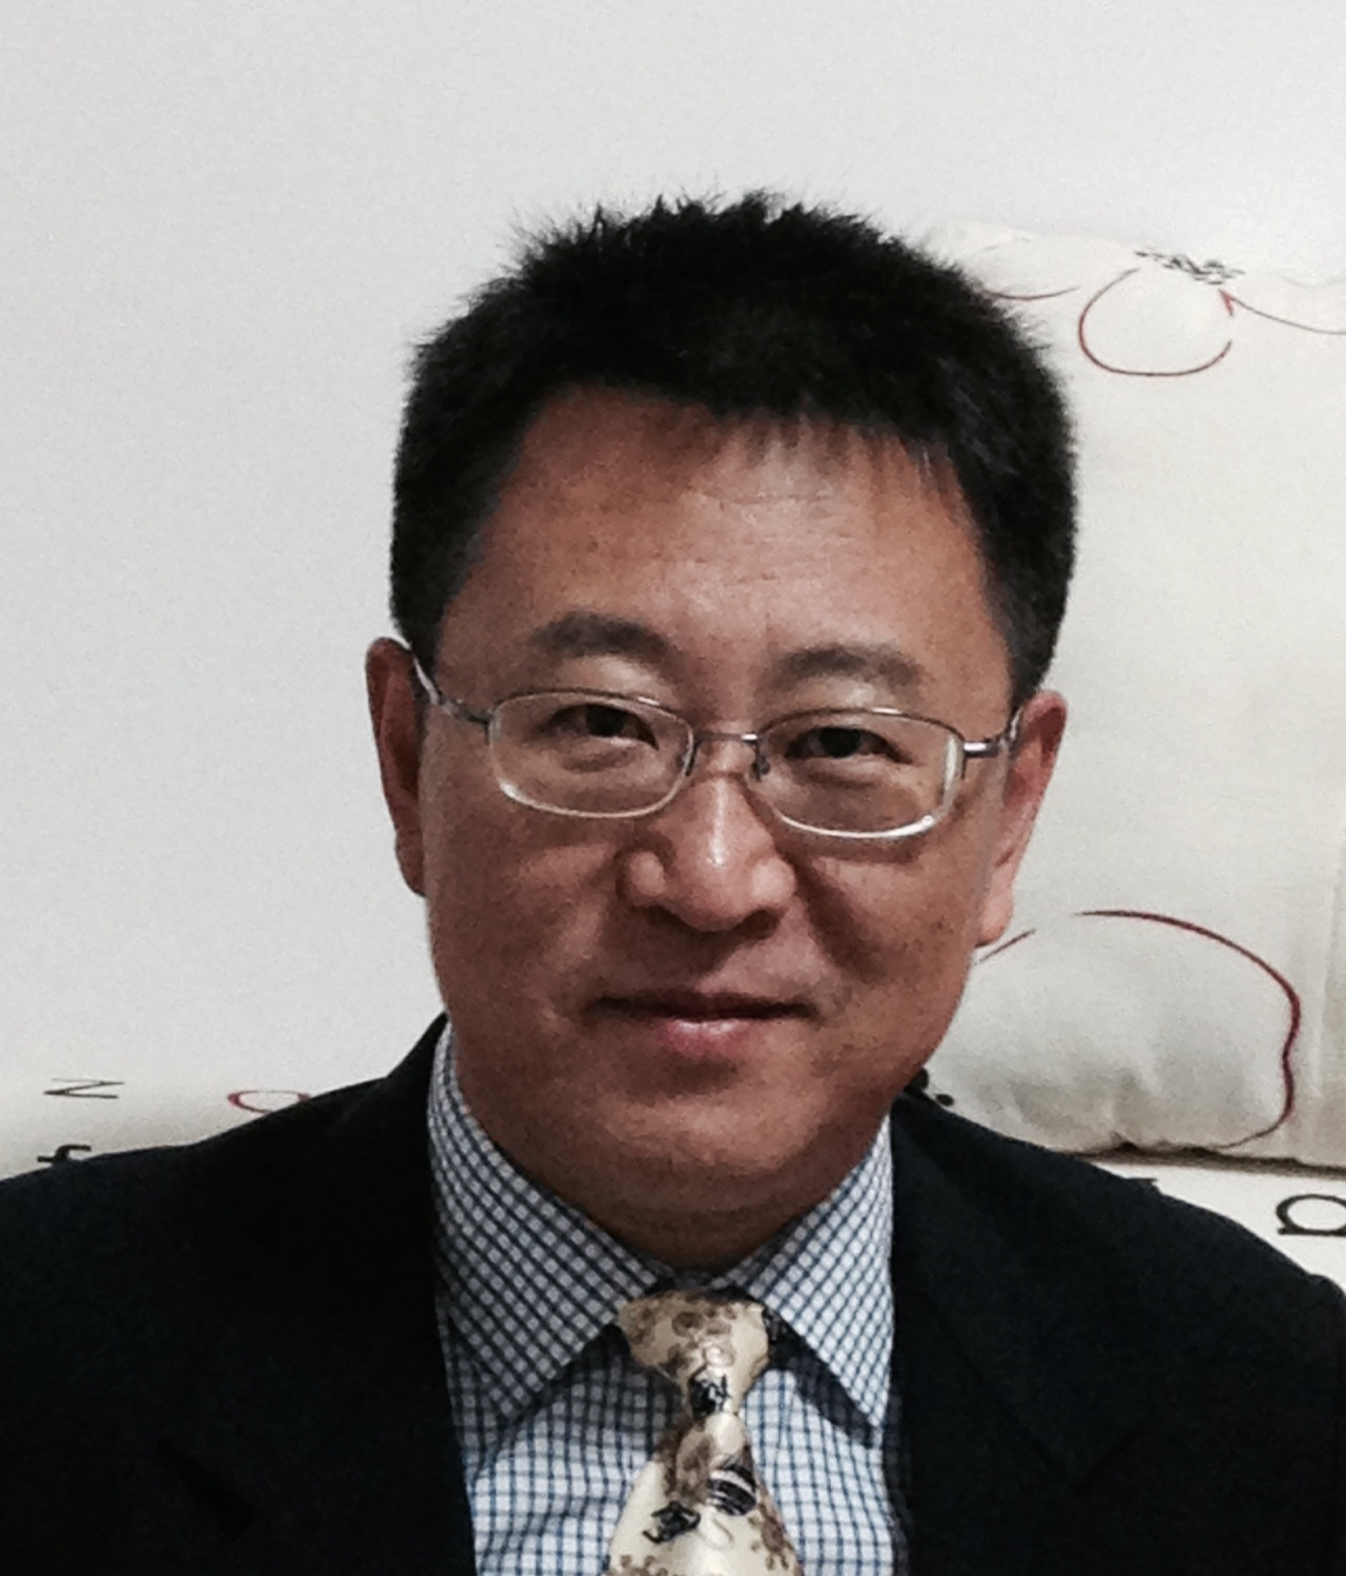
Changda Wang, Ph.D.
Associate Dean, Graduate School, Jiangsu University
Professor, Graduate faculty for Ph.D. and M.S. students
Zhenjiang, 212013, P. R. China
Education Background
Ph.D. School of Computer Science & Communication Engineering, Jiangsu University, P.R. China, 2006
M.S. School of Computer Science & Communication Engineering, Jiangsu University, P.R. China, 1999
B.S., Mathematical Department, Suzhou UNiversity, P.R. China, 1994
Working Experience
2014-Present, Associate Dean of Graduate School, Jiangsu University, P.R. China
1994-2014, Assistant Professor, Associate professor, Professor, School of Computer Science and Communication Engineering, Jiangsu University, P.R. China
Research Interesting
- Information Security
- Service computing
- Wireless Sensor Networks
Contacts
Email: changda@ujs.edu.cn; Tel: 86-511-88783018

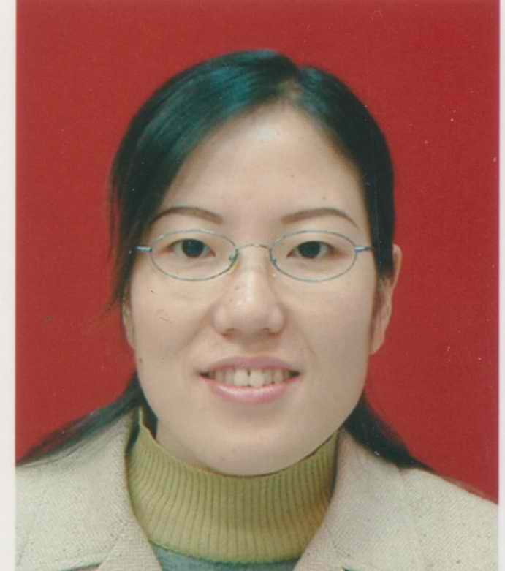
Qirong Mao, Ph.D.
Professor, Ph.D. and M.S. supervisor
Zhenjiang, 212013, P. R. China
Education Background
Ph.D. School of Computer Science and Communication Engineering, Jiangsu University, P.R. China, 2009
M.S., School of Computer Science and Communication Engineering, Jiangsu University, P.R. China, 2002
Working Experience
2015-Present, Professor, Jiangsu University, P.R. China
2009-2015, Associate professor, Jiangsu University, P.R. China
2004-2009, Lecturer, Jiangsu University, P.R. China
1999-2004, Assistant Lecturer, Jiangsu University of Science and Technology (now Jiangsu University), P.R. China
Research Interesting
- Multimedia Analysis
- Big data on Multimedia
- Human-Computer Interaction
- Affective Computing
- Intelligent Transportation
Contacts
Email: mao_qr@ujs.edu.cn; Tel: 86-511-88780371, Fax: 86-511-88780371

NAME: Lu Liu
TITLE and POSITION: Dr. / Professor
PHONE：+86-15062826336
E-mail：chinaliulu@hotmail.com
Curriculum Vitae
Lu Liu is a Specially-appointed Professor in the School of Computer Science and Telecommunication Engineering, Jiangsu University. He received a Ph.D. degree from the University of Surry (UK) and an MSc degree from Brunel University (UK). His current research interests include cloud computing, service-oriented computing, peer-to-peer computing, data analytics and online social networks. He is a Fellow of British Computer Society (BCS).
Research Orientation:
Distributed Systems
Cloud computing
Service-oriented computing
Peer-to-peer computing
Data analytics
Online social networks
Selected Courses:
Cloud Computing
Computer science and technology fundamental
Data Structure
Discrete Mathematics
Selected Project:
[1] July 2013 – June 2016: Research on Key Technologies of Resource Sharing for Next Generation of Online Social Networks, National Science Foundation of Jiangsu Province.
Professional Service:
(1) Associate Editor and Editorial Board Member, Journal of Peer-to-Peer Networking and Applications, Springer.
Selected Award:
- Best Paper Award, International Conference on Realising Network Enabled Capability, October 2008.

Fei Han, Ph.D.
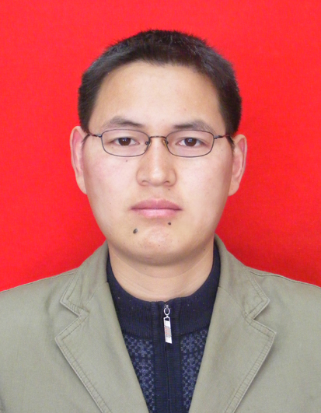
Professor, Dean of the Department of Computer Basic Education
Education Background
Ph.D., Department of Automation, University of Science and Technology of China (USTC), Hefei Anhui, China, 2006
MS., School of Computer and Information, Hefei University of Technology, Hefei, Anhui, China, 2003
Working Experience
2014-Present, Professor, School of Computer Science and Communication Engineering, Jiangsu University, P.R. China
2008-2013, Associate Professor, School of Computer Science and Communication Engineering, Jiangsu University, P.R. China
2010-2011, Visiting Scholar sponsored by China Scholarship Council, School of Computing, National University of Singapore, Singapore
2006-2007, Lecturer, School of Computer Science and Communication Engineering, Jiangsu University, P.R. China
Research Interesting
- Pattern Recognition
- Evolutionary Computation
- Intelligent Information Processing
- Bioinformatics
Contacts
Email: hanfei@mail.ujs.edu.cn; Tel: 86-511-8790321-533, Fax: 86-511-88780371

APPLICATION FORM FOR THE SCHEDULE
Comments of Discipline：

Person in charge（Signature）：

Date

Review opinion of college academic degree sub-committee:

Person in charge （Signature）：

Date

